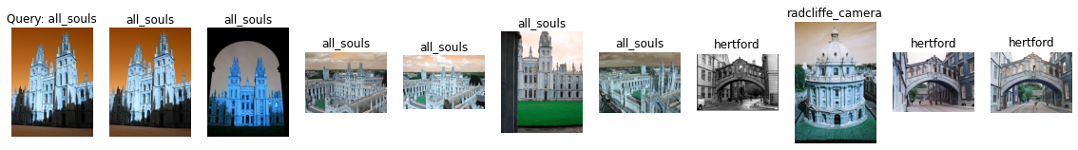

Label: all_souls

Average Precision for query 0: 0.45307722180054855

Precision@k for query 0: 0.6

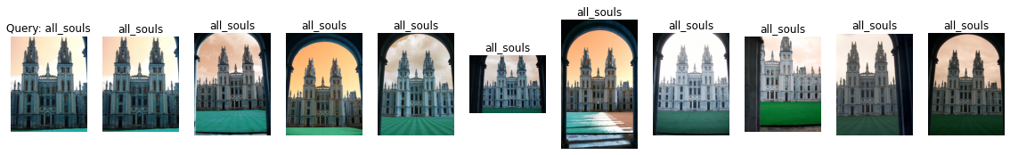

Label: all_souls

Average Precision for query 1: 0.5871905159662666

Precision@k for query 1: 1.0

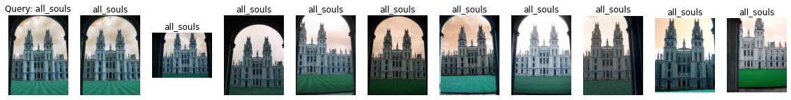

Label: all_souls

Average Precision for query 2: 0.6228634345751327

Precision@k for query 2: 1.0



Label: all_souls

Average Precision for query 3: 0.644349073320832

Precision@k for query 3: 1.0



Label: all_souls

Average Precision for query 4: 0.5994638760844376

Precision@k for query 4: 0.9

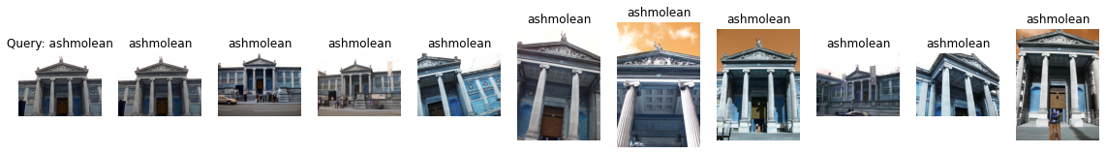

Label: ashmolean

Average Precision for query 5: 0.6157527174304607

Precision@k for query 5: 1.0

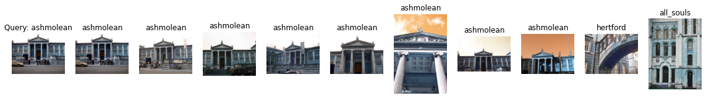

Label: ashmolean

Average Precision for query 6: 0.48383436721767303

Precision@k for query 6: 0.8

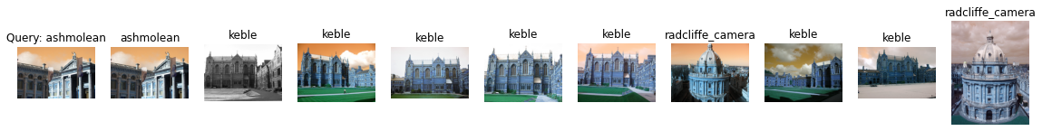

Label: ashmolean

Average Precision for query 7: 0.0936930520675713

Precision@k for query 7: 0.1

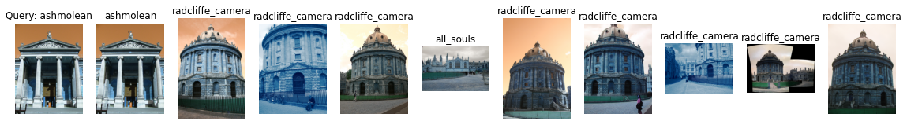

Label: ashmolean

Average Precision for query 8: 0.10353437549456078

Precision@k for query 8: 0.1

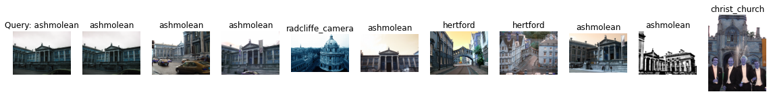

Label: ashmolean

Average Precision for query 9: 0.2753155312709955

Precision@k for query 9: 0.6

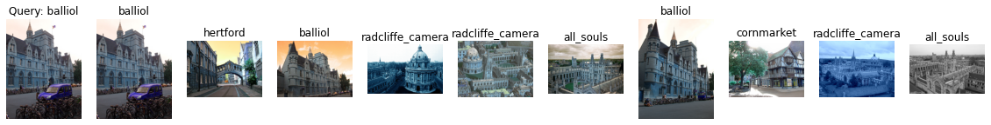

Label: balliol

Average Precision for query 10: 0.27541987719012506

Precision@k for query 10: 0.3

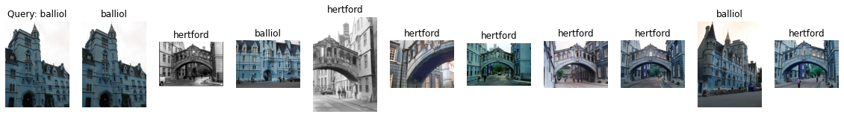

Label: balliol

Average Precision for query 11: 0.2904646664328498

Precision@k for query 11: 0.3

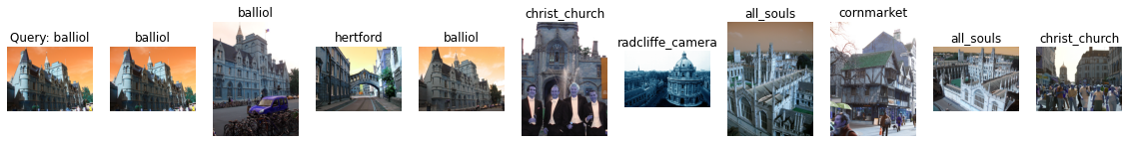

Label: balliol

Average Precision for query 12: 0.3439077001674173

Precision@k for query 12: 0.3

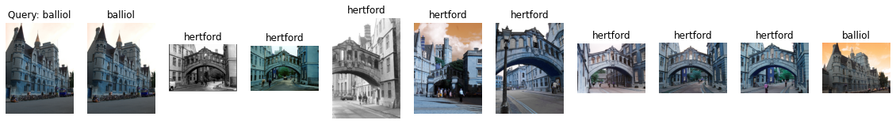

Label: balliol

Average Precision for query 13: 0.2183929863251218

Precision@k for query 13: 0.2

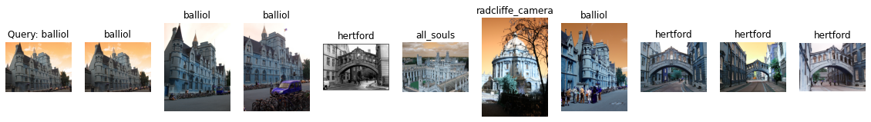

Label: balliol

Average Precision for query 14: 0.379475755439534

Precision@k for query 14: 0.4

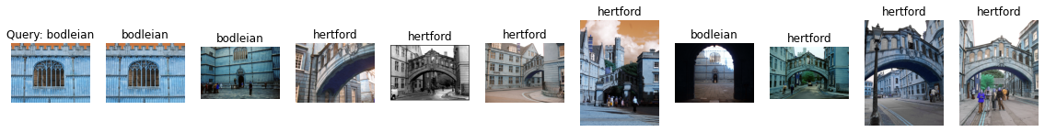

Label: bodleian

Average Precision for query 15: 0.20515683353662104

Precision@k for query 15: 0.3

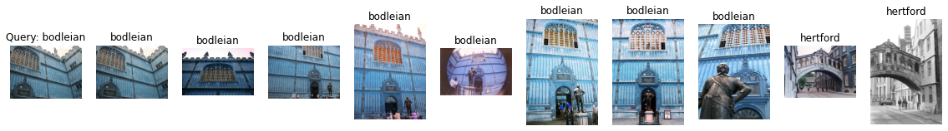

Label: bodleian

Average Precision for query 16: 0.41503895904721416

Precision@k for query 16: 0.8

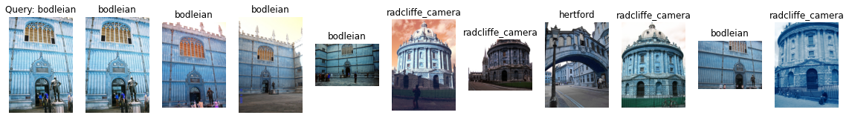

Label: bodleian

Average Precision for query 17: 0.23324880080217006

Precision@k for query 17: 0.5

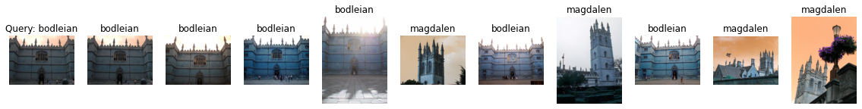

Label: bodleian

Average Precision for query 18: 0.30303456173156984

Precision@k for query 18: 0.6

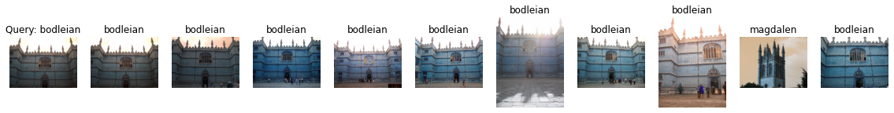

Label: bodleian

Average Precision for query 19: 0.6046602416181204

Precision@k for query 19: 0.9

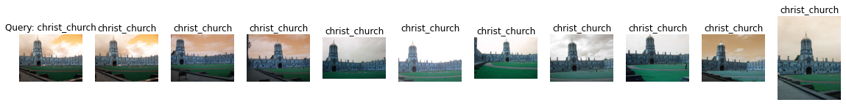

Label: christ_church

Average Precision for query 20: 0.6838219660610722

Precision@k for query 20: 1.0



Label: christ_church

Average Precision for query 21: 0.7607120142611128

Precision@k for query 21: 1.0



Label: christ_church

Average Precision for query 22: 0.7002278518636225

Precision@k for query 22: 1.0

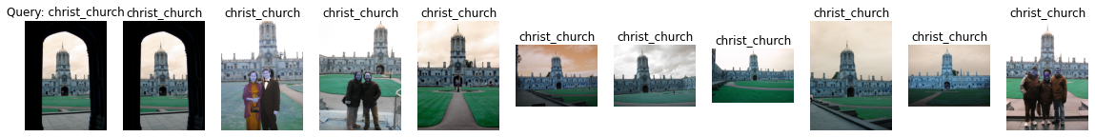

Label: christ_church

Average Precision for query 23: 0.5407846320555315

Precision@k for query 23: 1.0

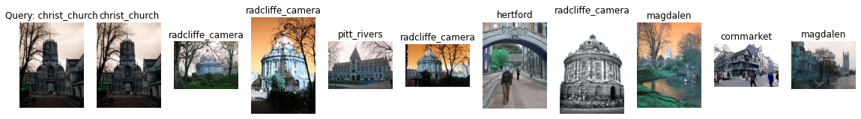

Label: christ_church

Average Precision for query 24: 0.10829979923993903

Precision@k for query 24: 0.1

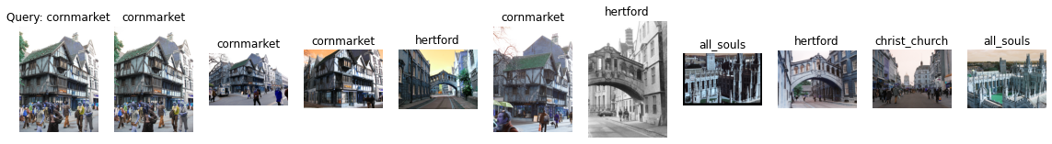

Label: cornmarket

Average Precision for query 25: 0.47630895100997567

Precision@k for query 25: 0.4

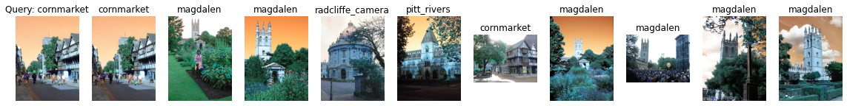

Label: cornmarket

Average Precision for query 26: 0.19684436559557408

Precision@k for query 26: 0.2

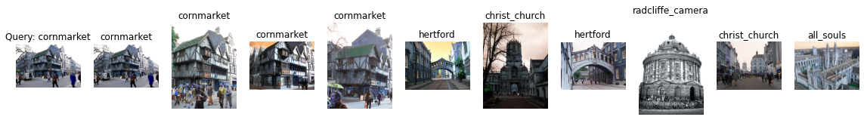

Label: cornmarket

Average Precision for query 27: 0.5159521608980508

Precision@k for query 27: 0.4

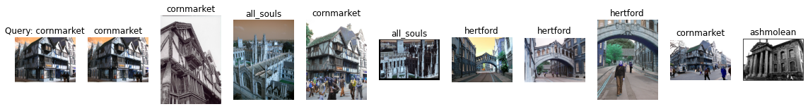

Label: cornmarket

Average Precision for query 28: 0.40979093646956993

Precision@k for query 28: 0.4

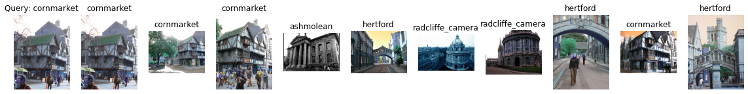

Label: cornmarket

Average Precision for query 29: 0.49265769260758013

Precision@k for query 29: 0.4

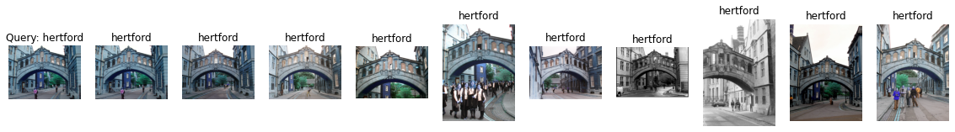

Label: hertford

Average Precision for query 30: 0.7126302212055938

Precision@k for query 30: 1.0

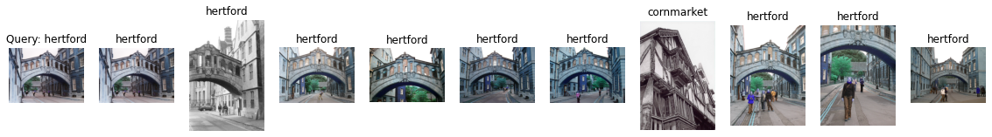

Label: hertford

Average Precision for query 31: 0.609174700285785

Precision@k for query 31: 0.9

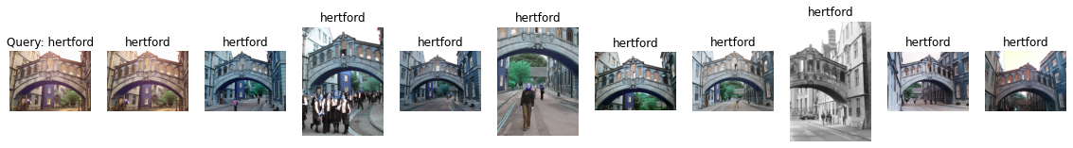

Label: hertford

Average Precision for query 32: 0.5640854862519694

Precision@k for query 32: 1.0

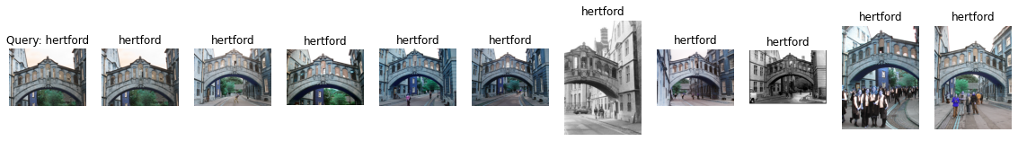

Label: hertford

Average Precision for query 33: 0.6213103403579932

Precision@k for query 33: 1.0

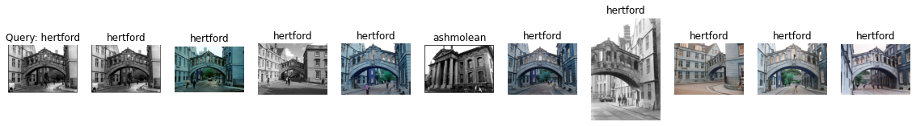

Label: hertford

Average Precision for query 34: 0.7105421921569736

Precision@k for query 34: 0.9



Label: keble

Average Precision for query 35: 1.0

Precision@k for query 35: 0.7



Label: keble

Average Precision for query 36: 1.0

Precision@k for query 36: 0.7



Label: keble

Average Precision for query 37: 1.0

Precision@k for query 37: 0.7

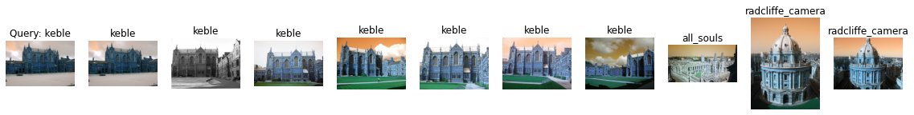

Label: keble

Average Precision for query 38: 1.0

Precision@k for query 38: 0.7



Label: keble

Average Precision for query 39: 1.0

Precision@k for query 39: 0.7

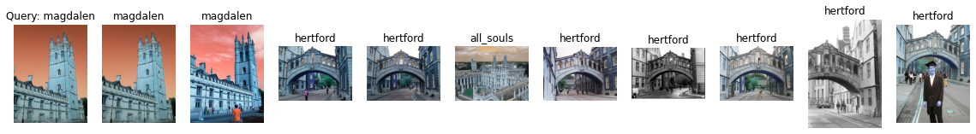

Label: magdalen

Average Precision for query 40: 0.10073996011869922

Precision@k for query 40: 0.2

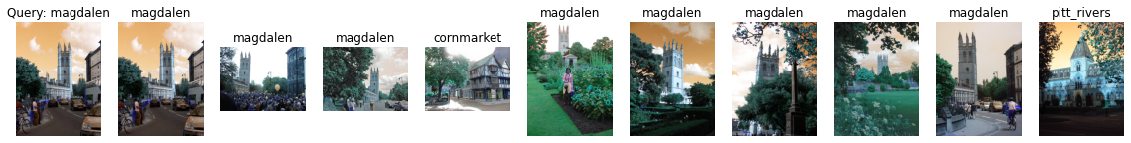

Label: magdalen

Average Precision for query 41: 0.3585874389431679

Precision@k for query 41: 0.8

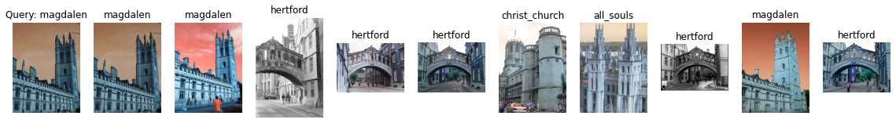

Label: magdalen

Average Precision for query 42: 0.11188193904467306

Precision@k for query 42: 0.3

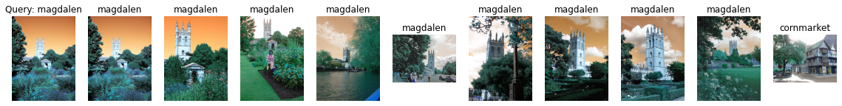

Label: magdalen

Average Precision for query 43: 0.5175172772877316

Precision@k for query 43: 0.9



Label: magdalen

Average Precision for query 44: 0.16212350298552067

Precision@k for query 44: 0.3

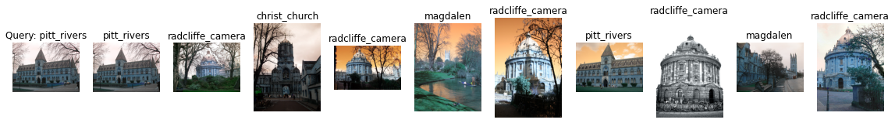

Label: pitt_rivers

Average Precision for query 45: 0.2279070189702307

Precision@k for query 45: 0.2

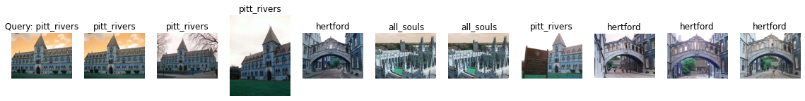

Label: pitt_rivers

Average Precision for query 46: 0.6396825396825397

Precision@k for query 46: 0.4

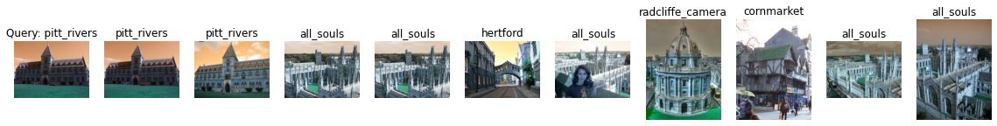

Label: pitt_rivers

Average Precision for query 47: 0.4026530938290129

Precision@k for query 47: 0.2

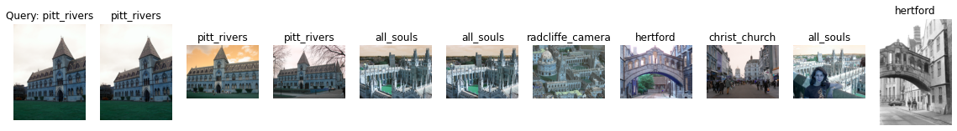

Label: pitt_rivers

Average Precision for query 48: 0.5754558404558404

Precision@k for query 48: 0.3

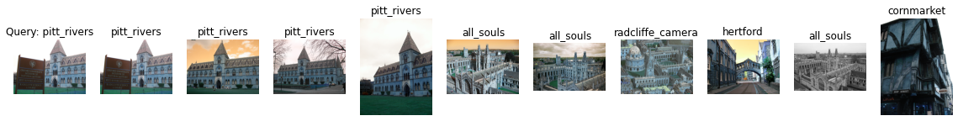

Label: pitt_rivers

Average Precision for query 49: 0.7407622739018088

Precision@k for query 49: 0.4

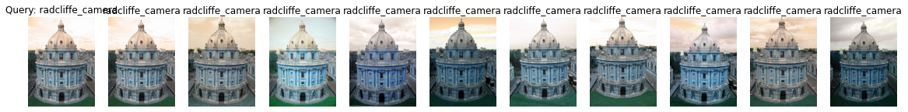

Label: radcliffe_camera

Average Precision for query 50: 0.6895039458442813

Precision@k for query 50: 1.0



Label: radcliffe_camera

Average Precision for query 51: 0.7749381121996216

Precision@k for query 51: 1.0

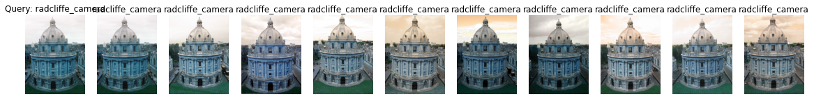

Label: radcliffe_camera

Average Precision for query 52: 0.7206925053328521

Precision@k for query 52: 1.0



Label: radcliffe_camera

Average Precision for query 53: 0.7782923648701288

Precision@k for query 53: 1.0

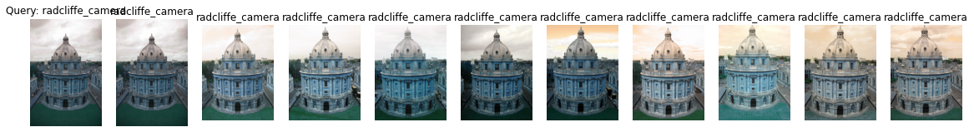

Label: radcliffe_camera

Average Precision for query 54: 0.7306185888861897

Precision@k for query 54: 1.0

mAP = 0.5160431683671248